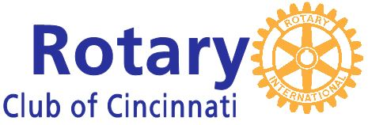  Breakfast Social  ~  Prospective Member Event  Free to invited guests and those Rotarians who  bring prospective members. | Hyde Park Golf & Country Club  3740 Erie Avenue  Cincinnati, Ohio 45208  (Prospective Member Event)

Date: Wednesday, February 7, 2018
Time: 7:30 a.m. – 8:45 a.m.
Where: Hyde Park Country Club
3740 Erie Avenue, Cincinnati, Ohio 45208
RSVP by Friday, February 2, 2018 to office@cincinnatirotary.org
For additional information regarding the Rotary Club of Cincinnati, contact personnel at the office 513.421.1080
Website ~ www.cincinnatirotary.org

