

This week's meeting sponsor is............

Bayer Becker grew from two entrepreneurs who saw a need in the marketplace and had the drive to build it from the ground up. Founded on strong values and a commitment to the client, you can find the that same entrepreneurial spirit today in every level of the organization, from principal to technician. This has positioned Bayer Becker as an industry leader, providing innovative and practical solutions, for almost 50 years.
Our firm offers integrated professional design consulting services, including civil engineering, transportation engineering, land surveying, landscape architecture and planning. Our collaborative approach, extensive local network, and commitment to technology ensure that we are an advocate for our clients and are continuously designing for success.
-------------------------------------------------------------------------

Thursday, June 29, 2017
THE CHANGING OF THE GUARD
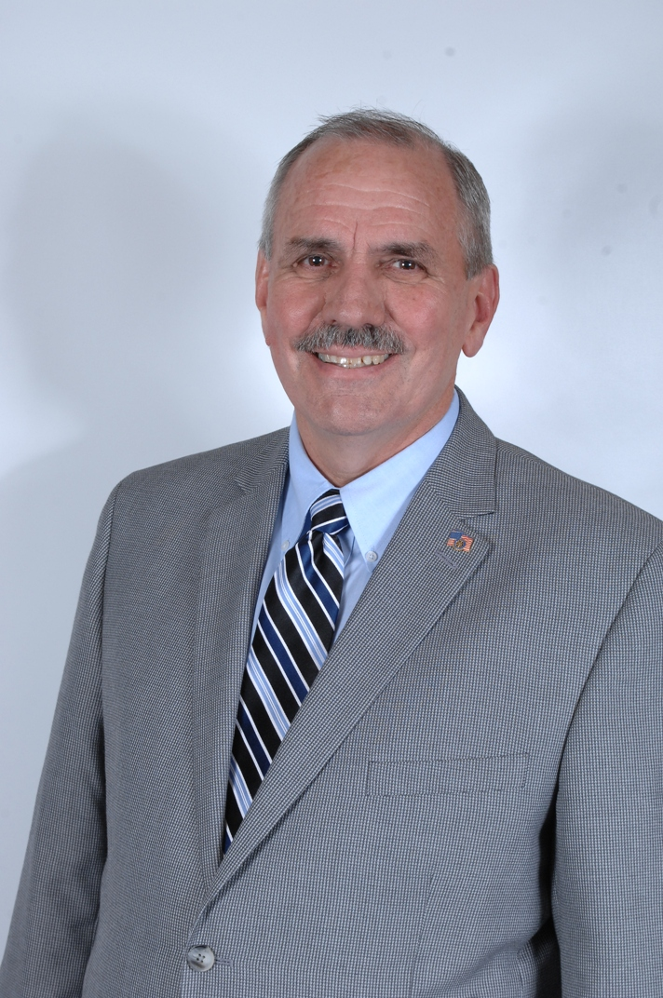  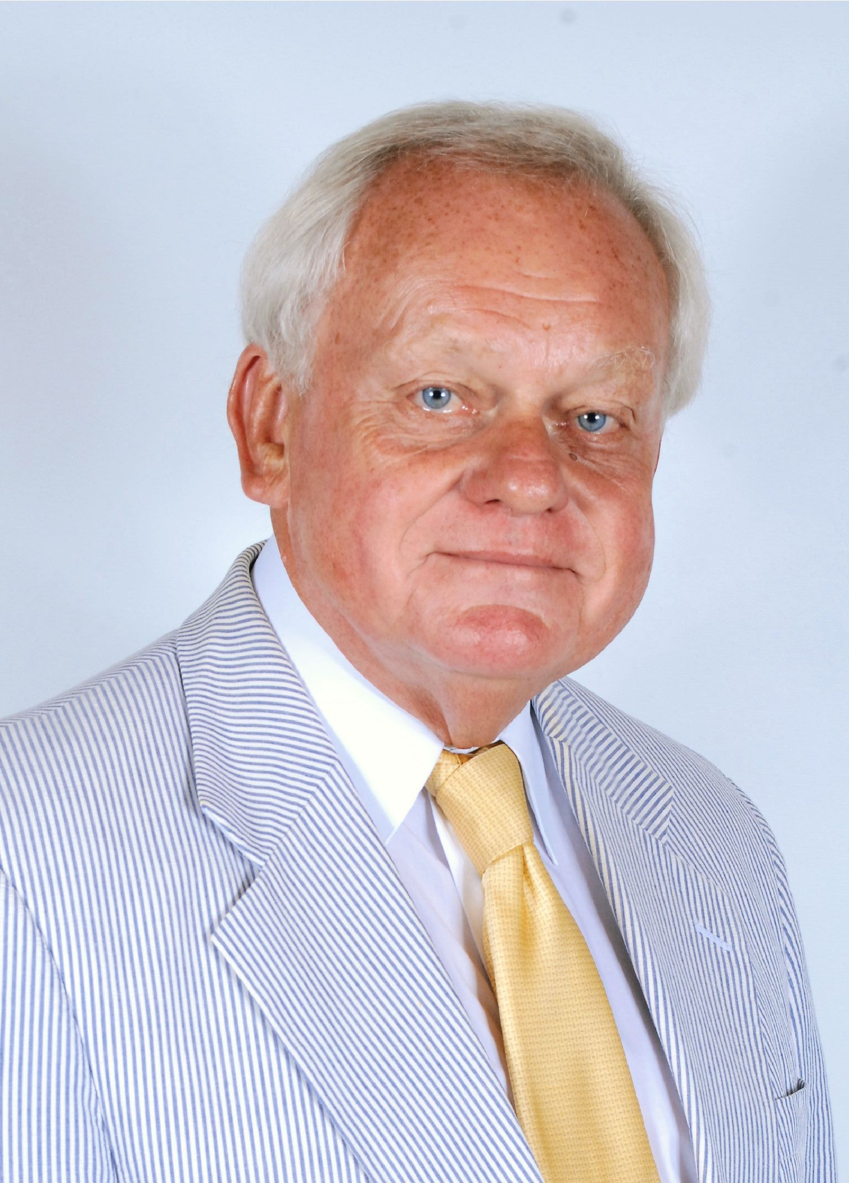
Join us as we thank President Jack Scott for his year of service and officially welcome President Al Koncius as he begins his year. We will also recognize those who have served on the Board and as Committee Chairs this past year.
Location: Hall of Mirrors
Menu: Arugula salad with candied almonds, blueberries, ricotta salata & rasberry vinaigrette; roasted pork loin, roasted garlic whipped potatoes, asparagus & mustard jus; and white chocolate mousse.
Alternate Menu: Tempura vegetables, roasted garlic whipped potatoes, asparagus & mustard jus OR June Salad - Grilled chicken on summer greens with grilled zucchini, roasted tomato, & mustard vinaigrette.
This Week's Birthdays:
June 26 - Jim Brooks jbrooks@pods.com
June 27 - Carl Coburn ccoburn@cshco.com
June 28 - John Neyer jneyer@hgcconstruction.com
This Week's Meetings:
11:15 a.m. New Member Orientation, Julep Room, 3rd FL
12:00 p.m. Committee Chairs, Salon M, 4th FL
1:30 p.m. New Member Advisors, Salon M, 4th FL
2017 Member Anniversaries (with 5 year increments):
JUNE -
Chris Allen - 5 Years!
John Steine - 5 Years!
Bill Stille - 5 Years!
Bob Buechner - 10 Years!
Arne Almquist - 15 Years!
Larry Cunningham - 15 Years!
Russell Smith - 15 Years!
Bud Dornette - 35 Years!
Bob Wilson - 35 Years!
Rotary Traveling Wheels
It seems that all of our Rotary traveling wheels have gone missing again! If you previously checked one out to take on a vacation and are finished with it, please return it to the Rotary Office or to the next Rotary meeting. Thank you for your help with this!
Membership Survey: Interests & Hobbies
Our Club is conducting a survey of all members to build database of member interests and hobbies above and beyond our dedication to "Service Above Self". We hope to use this information to create new activities, special outings and events that enable Rotarians (and their significant others!) to enjoy greater fellowship with one another. If you missed filling out a Member Interest Survey at our meeting last week...please click here: SURVEY to fill out this fast survey. We had a tremendous response last week and we don't want to miss anyone!
Program: To Be Announced
Location: Hall of Mirrors
Menu: Bibb lettuce with tomatoes, mozzarella, pine nuts & balsamic vinaigrette; bourbon chicken, scallion white rice & broccolini; and brown butter cake with caramel.
Alternate Menu: Tempura vegetables, scallion white rice & broccolini OR July Salad - Grilled chicken on chipped iceberg & cabbage with scallions, carrots, tomatoes & ginger dressing.

